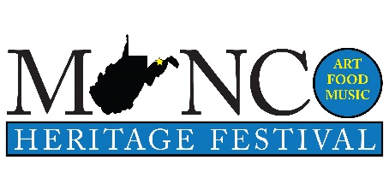
Entertainment Form
Fri/Sat/, May 16/17, 2020

Name of Performer or Group
Contact Person
Email
Phone Number
Does this number receive texts?
Type of Music (Genre)

Tell us your story: (Where you are from, including all members of the group), How long have you been playing together, any special venues that you have played, are you affiliated with other groups, etc. We would like to use this information in our news releases and advertising. Include another page if necessary!

Please attach a photo (link, digital or print) if available.

Any special needs that we can help with?

Please provide the Day and time of day that would be most agreeable with you to play.

For any questions or information please contact Terry Stephens at 304-813-5740 or mincomusicheritagefestival@gmail.com or mail to Minco Music Festival, 315 Chestnut Hill, Keyser, WV 26726. More info at: www.mincomusic.weebly.com

Minco Music Heritage Festival is promoted by Highland Arts Unlimited, a 501c3 nonprofit community organization. We will not be charging admission for the festival and we will try to accommodate everyone as best possible. Sets will be approximately 45 minutes in length. We will try to find sponsors for you if you have to have expense money to appear. This is a first-year festival and we hope that you will be patient with us. THANKS!

